Lab 04:

A Comprehensive Reconnaissance of AirBnB.com

Seth Ayers

Angelo Rivieccio

Djordje Vrankovic

IT 430 – 02

Professor Paul-Marie Moulema Douala

02/23/2018

**Recon-ng**

**Overview:**

The goal and main function of recon-ng is to provide users with a framework that quickly and efficiently provides passive reconnaissance for social engineering. Aside from social engineering, the information provided by the queries can be used as a starting point in determining the starting point when performing active information gathering/scanning. Although Recon-ng comes with a few pre-built modules “out of the box”, developer API’s can increase the capabilities of the tool enhancing and refining the information scanned. Recon-ng is python based, open source, and can be considered the command line equivalent to the GUI based Maltego.

**Results from various scans of AirBnB.com:**

Recon-ng has the capability to a scan domain for hosts related to the domain. The tool can also use other search engines via API access to broaden the scope of the results, as well as a brute force option to maximize results. Unless the naming conventions are unconventional, you can identify the purpose of the hosts just by the name. In my hosts scan of AirBnB (figure 1.), I could easily identify the apparent nature and purpose of the hosts just from the naming conventions; email, admin, assets, etc.

Although the names of the hosts can provide some vital information to the nature of the scanned hosts, we require a way to access these hosts if we do decide to perform a more aggressive/active approach in terms of scanning. Performing a resolve of the host name can give us the IP address of the host (figure 2.). These IP’s can also give us the ability to roughly pinpoint the locations of the hosts, providing city and state information as well as a more exact latitude and longitude location (figure 3.). These passive locations results are useful in various ways, depending how active the investigation is. The locations can be scouted (for physical security flaws, employee observation), dumpster dived, or even broken into to steal critical and sensitive hardware. Use of the recon-ng social media pushpin modules can possibly provide even more information, which I will go over shorty, in detail.

Social engineering plays a large part in active reconnaissance and in order to perform the recon effectively, we need to know as much as possible about our target’s employees. Recon-ng allows us to perform a whois scan of the point of contacts listed in ICANN databases quickly and effectively. Names and locations of these individuals gives us a starting point in which more information can be “dug up” to discover log in names, answers to password recovery questions (name of dog, mother’s maiden name, place of birth), or social media access. In more aggressive footprinting, the target individual can be physically followed and observed, possibly providing more information that would be useful in impersonation. Interestingly, when I scanned my host lists for AirBnB.com, I discovered only two full names, Jason Galanter and Michael Anderson (Figure 4). There were two Admin contact emails listed but no full names were provided. However, looking at rowid 5, we see that one of Jason’s emails uses the naming convention of [jmg@airbnb.com](mailto:jmg@airbnb.com). Knowing this, we can assume that the Admin emails (Rowid 1 and 2) use the same naming convention of first middle last initial of the user’s full name. We can then use this information to locate AirBnB employees whose names match these emails and conduct further reconnaissance.

The social media pushpin modules of recon-ng take the passive recon abilities of the tool to a refined and detailed level, searching website for photographs metadata that matches the parameters of that the user inputs. This can also be done effectively with tweets if the tweet was made with location services turned on. Unfortunately, recent changes to the Facebook and Instagram API’s make it impossible virtually impossible to search unless the request for the API is approved via a vetting/approval process. Being said, using the Flickr and Twitter API’s provided plenty of useful information to sift through. Although the host locations could potentially be useful to scan, I chose to google the main headquarters of AirBnB for an address (figure 5). Instead of giving a general latitude and longitude, an exact address will provide a precise location of the target, and in turn, exact locations of extracted photo and social media metadata (figures 6 and 7). Once recon-ng has assigned the coordinates, we can use our social media pushpin modules to scan media and tweets in that defined area (figures 8 and 9). Lastly, the information gathered can easily be arranged to a map and info graph, allowing for simplified visual representation and searching, as opposed to searching via command line (Figures 10, 11, and 12). With that visualization of the scanned metadata, we can begin to target specific employees with distinct pins. Seeking and following social media accounts, probing for personal information, uncovering “slip-ups” that may have been inadvertently shared involving operational security, or finding more active scanning options is made a possibly thought the pushpin modules.

**Advanced Google Search/Google Hacking**

**Overview:**

Although we have a vast array of footprinting tools at our disposal through online websites and the modules located in Kali Linux, a few of these applications have the chance of alerting the target, jeopardizing the entire reconnaissance effort. Preforming reconnaissance through advanced google search functions is a great way to maintain a low profile without risking discovery. It’s also available to almost anyone with access to an internet browser. The information can prove to be extremely useful, especially if you’ve done previous footprinting on the target and choose to refine the searches to get more details. There is a downside to using the Google search functions, however. Although the commands allow for highly specialized searches and searched data, reconnaissance tools provide a faster means of obtaining information on a target with much less redundant or unrelated hits to sift through.

**Results from the advanced Google search of AirBnB:**

The sheer amount of information that can be discovered by performing advanced Google search functions can be overwhelming, especially with a large company like AirBnB. I approached these searches with a few core goals in mind; verify some the results of the recon-ng scan to ensure that some vital information wasn’t missed, gain potentially useful information on employees that can be used for social engineering, and dig deeper into admin email addresses.

Firstly, I want to ensure my scan of admin.airbnb hosts with recon-ng was accurate and that I wasn’t missing important information. To check this via Goggle search, a site crawl is required. This method of advanced search involves using a site operator with the domain name and taking away the www out of the search results. Once the search results populate, the redundant information is removed, and the search is performed again. This is continued until the returned results match the needs of the scanner. Figure 1 shows the process of site crawling and figure 2 displays the results. Since the search results only really show one admin host, admin.airbnb/*, it is safe to assume that one of the admin hosts on the recon-ng scan may be redundant or a duplicate hit.

The recon-ng whois_poc scan only can up with a few results, and only one full name; Jason Galanten. If this individual is listed as the point of contact of the Airbnb hosts, it’s important to know as much as possible regarding this individual. Using advanced Google hacking, I was able to find the individuals LinkedIn profile which provided a large amount of data, including a face exact location to the name (Figure 3). Further investigation revealed that the individual left his position at Airbnb in 2017. Knowing that this lead might be a dead end, I searched LinkedIn for current Information Technology admins that are employed by Airbnb, which provided plenty of individuals that could be used to impersonate or target further (figure 4).

Reviewing the POC contact list once more, I felt the admin emails that had no names attached were worth looking into as well. Searching the [rir@airbnb.com](mailto:rir@airbnb.com) email didn’t provide much in terms of links, however there was one image file associated with the email shown in figure 5. The figure appears to be a IPv4 route propagation diagram for servers in the UK and the information it provides and give some insight into the internal network infrastructure.

**Social Media Network Search**

**Results from social network search:**

Social networking websites can be used to find a lot of personal information that is available to anyone. Many people post information that is personal without thinking twice. After finding out through recon-ng that there were two admin accounts that stood out for airbnb.com, we investigated further into these two admins. We started with Jason Galanter. Jason Galanter was a former lead IT architect at Airbnb. He left in January 2017 to join Fragomen. At Airbnb, he was the main architect that oversaw sure voice, video, network, storage, and core systems (Figure 23). It is a little strange that he still comes up when doing the whois command. They might have forgotten to remove his account when he left the company. If his account is still active within their system, this is a very good point of weakness.

The other admin that came up was Michael Anderson. After doing some extensive research using Zabasearch, LinkedIn, Intelius, and Familytreenow we were able to find addresses, phone numbers, and possible relatives associated to him (Figure 24,25). His current title at Airbnb is network, voice, video, and collaboration services manager. Michael Anderson was very active on Facebook until July 16,2016. He has the addresses that he has lived at publicly available on his profile (Figure 24). With this information we could find phone numbers that are possibly associated with him. The only issue was that his name was very common so we found plenty of people around his age living in the same cities that he lived in. He also has around 400 places listed in his check-ins section on Facebook. You could use this information to do social engineering with some of these places to find more information on him.

He also had images of his two children, Oliver and Sage, that were holding up either a picture or a certificate with their school names on there. We could find the exact schools by finding one of them and then checking all schools in that district and both Katherine Elementary School and Hillside Middle school were there (Figure 26). It also confirmed that those were the schools that the children have gone to because those schools were located in Simi Valley, California and he was part of a dance group called the “Actor’s Repertory Theatre of Simi” (Figure 25). Since Michael Anderson has been inactive on Facebook since the summer of 2016, you could use the information of these schools to clear up where his actual address is by doing social engineering and asking the school to check if they have the right address on file. We also figured out that his daughter’s birthday is either on May 21 or 22 and that his son’s birthday is on December 19. He also posted multiple times about a dance competition that his children were involved in. We were able to find the schedule of that dance competition (Figure 27). This information could be used to try to guess his passwords by using something similar to his children’s names, the numbers from his children’s birth dates, or something to do with tap dancing.

We also looked into some different employees there to get more insight. I looked into Justin K. Chen who is a software engineer at Airbnb (Figure 18). I was able to see what kind of software they are running there. Python and Ruby on Rails were the most popular. Another software engineer was Joseph Sofaer (Figure 19). We were able to find his address, phone number, possible relatives. On his LinkedIn profile, we were able to find Ruby on Rails once again. You could use this information to look at the biggest vulnerabilities of the different software. Harrison Shoff is also a software engineer currently at the company. We could also find possible associates and relatives as well as addresses that he resided at (Figure 20). There was also a data scientist at Airbnb named Aaron Keys which had plenty of programs in the job description of his LinkedIn profile as well as a comment from a former employee (Figure 22). The last engineer we looked at was Tommy Dang. He runs his own website. This can be used to also evaluate his website and find vulnerabilities. If his website is not secure you might be able to find some kind of information regarding him (Figure 21).

I also took a look at the job openings they had on their website to try to determine what other systems they are using. Some of the programs that were mentioned were Kamailio/OpenSER/OpenSIPS, SIP/RTP, H323, Cisco UCM, SQL, R/Python, Ruby on Rails and Java. You could use this information to look up the vulnerabilities of the different programs to focus on exploiting the weaknesses.

**Whois**

**Overview:**

Whois is a query and response protocol that is widely used for querying databases that store the registered users or assignees of an Internet resource, such as a domain name, an IP address block, or an autonomous system, but is also used for a wider range of other information.

**Results from Whois Scans of AirBnB.com:**

When searching for the domain of airbnb using Whois airbnb.com I received multiple different types of information. For starters, I got the domain name for the website of course, the registry domain ID and the WHOIS server airbnb is located on which was markmonitor.com. There was also a creation date for the domain which was 8/5/2008 12:29 am and the most recent updates to the domain itself which was 12/14/2017 at 8:16 pm. There was information on the registration expiration date as well which ends promptly at 8/5/2020 at 12:29 am. (Figure 28)

After that information I saw a lot about the registrant ID itself. The Domain Administrator was the name of the registrant from the Airbnb organization. The exact location of where it was created as well which was 888 brannan street, san francisco, california on the 4th floor of the building located at that address. Along with that information on the location there was also the postal code was 94103 and the phone number 1(415)-728-0000 and the email is domain@airbnb.com. Looking deeper into the person who got the server he himself is a Domain Administrator located at 3540 East Longwing Lane, Suite 300, Meridian, Idaho, postal code 83646, and his number is 1(208)-389-5740. (Figure 29)

Using the command for the IP Address 205.233.29.121 (Whois 205.233.39.121) I was able to find some more emails and references to other individuals in the company such as [rir@airbnb.com](mailto:rir@airbnb.com) and their reference was <https://whois.arin.net/rest/poc/AIRBN-ARIN> and also within that information it was noted that the individual was an Airbnb Admin with the organization phone number 1(408)-649-0715. The IP registration was different from the domain registration. The dates of registration were 10/25/2011 and was last updated 7/23/2013 but overall the information on the location was the same but actually gave less information about the floor of which the IP Address was located. (Figure 30)

**Netcraft**

**Overview:**

Netcraft provides web server and web hosting market-share analysis, including web server and operating system detection. In some cases, depending on the queried server's operating system, their service is able to monitor uptimes;  uptime performance monitoring is a commonly used factor in determining the reliability of a web hosting provider. Netcraft has explored the internet since 1995 and is a respected authority on the market share of web servers, operating systems, hosting providers, ISPs, encrypted transactions, electronic commerce, scripting languages and content technologies on the internet.

**Results from Netcraft Scans of AirBnB.com:**

Within looking on the netcraft site I found a good amount of information on the site and who is prevalent on the domain. There was an IP address associated with the netcraft lookup, and of course there needed to be a whois command done on this address(2.16.56.90). A company that seemingly possibly distributed the IP address to Airbnb named Akamai Technologies based out of the EU they were created in 12/12/2010 and was also last modified on that same day. The exact location of this company was also given to us which is 8 Cambridge Center, Cambridge, Massachusetts, postal code 02142 with the phone number 1(617)-938-3130. This branch of the company was created in 3/6/2002 and was last modified 7/12/2017. (Figure 31)

The information given from Netcraft searches showed that the Netblock owner is Akamai technologies. A netblock is basically a range of IP addresses that a specific ISP or datacenter owns, and can assign at will. In the context of digital advertising, netblock mapping tables power things like ISP targeting. The name server is ns1.p74.dynect.net, A name server is a specialized server on the Internet that handles queries or questions from your local computer, about the location of a domain name's various services. Also information on the Reverse DNS was found a2-16-56-90 deploy.akamaitechnologies.com with the hosting company also being Akamai technologies and the hosting country being the European Union. (Figure 32)

Web trackers found on the website was strictly Google.com.Website tracking refers to the act of archiving existing websites and tracking changes to the website over time. Many applications exist for website tracking which can be applied to many different purposes. Server side technologies on the site are XML and SSL. SSL is an cryptographic protocol providing communication security over the Internet and XML is a markup language much like HTML. On the Client Side there was only one used technology which was JavaScript. Javascript which is a widely-supported programming language commonly used to power client-side dynamic content on websites. (Figure 33)

**Shodan**

**Results from Shodan:**

Shodan is a search engine that can help you find more information about a specific domain. When you search Airbnb.com on Shodan then it gave me three different IP addresses as well as their coordinates (Figures 34,36,37). It also showed some of the ports that were recognized. You can also look at the details of each port that was listed (Figure 35). It will give you different types of information like the content-length and the connection. You could use the information about what ports are being detected to do attacks specifically directed on those ports. After looking up the different coordinates that were provided, the only one that was in an area that made sense was the IP address of 35.184.116.240. There was a NASA supercomputing division very close by. The other two were in areas that didn’t seem reasonable for any type of server to stay. It could have been a bit further away from the actual coordinates because it is not always fully accurate to get a location from an IP address. It also gives the top cities, services, organizations, domains, and SSL versions (Figures 38,39). You can use this information to look at all the vulnerabilities of all the different services and SSL versions.

**Figures and Appetencies**

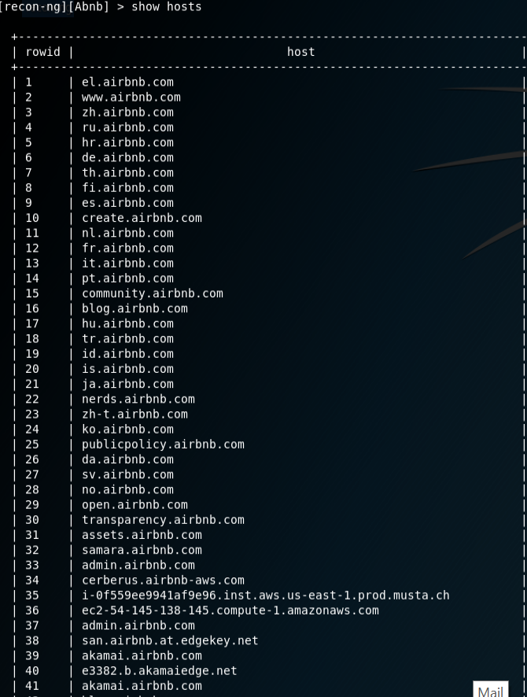

*Figure 1.* A screenshot of the list of hosts relevant to the Domain, AirBnB.com. Commands used to obtain list: recon/domains-hosts/google_site_web, recon/domains-hosts/bing_domain_web, recon/domains-hosts/bing_domain_web, recon/domains-hosts/bing_domain_web.

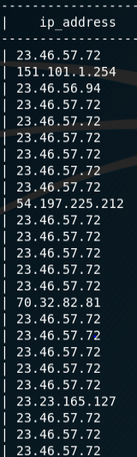

*Figure 2*. Screenshot of IP addresses that were resolved from the host names. Commands used: recon/hosts-hosts/resolve, recon/hosts-hosts/reverse_resolve.

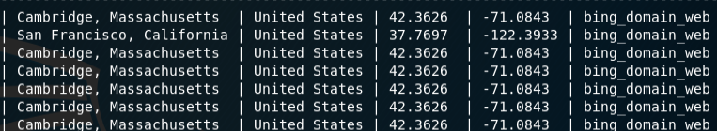

*Figure 3*. Screenshot of host locations along with latitude and longitude coordinates, resolved from the IP addresses. Commands used: FreegeoIP module.

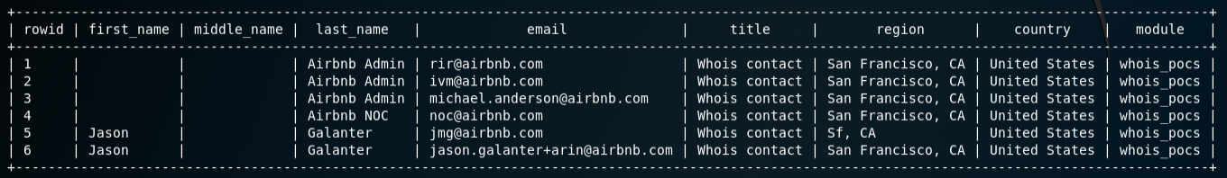

*Figure 4*. Screenshot of all point of contact information for the hosts that are registered in the ICANN database. Commands used: whois_poc module.

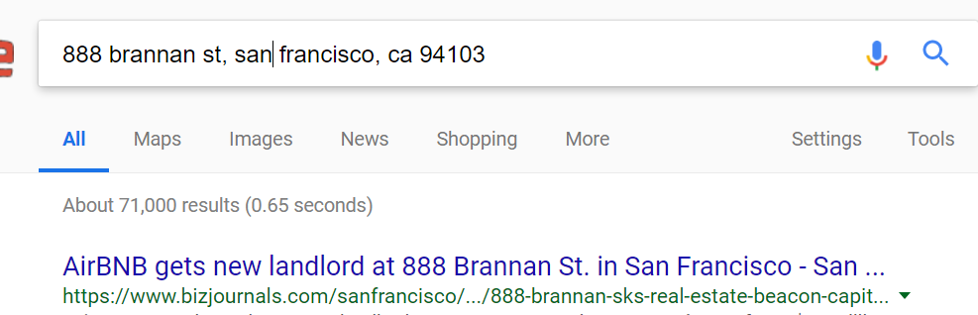

*Figure 5*. Google results of the Headquarter address of AirBnB.

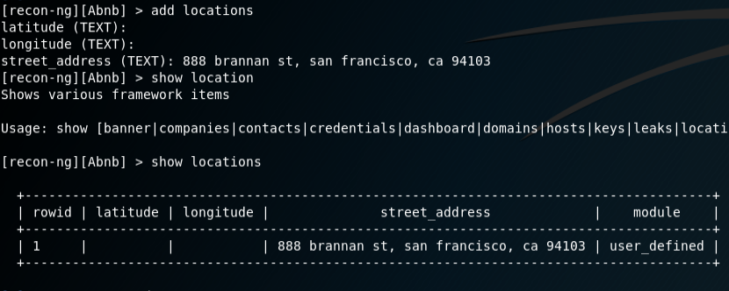

*Figure 6*. Screenshot of target address being loaded into the SOURCE table. These parameters are required for pushpin commands. Required input: street_address. Further inputs not required, as shown in figure 7.

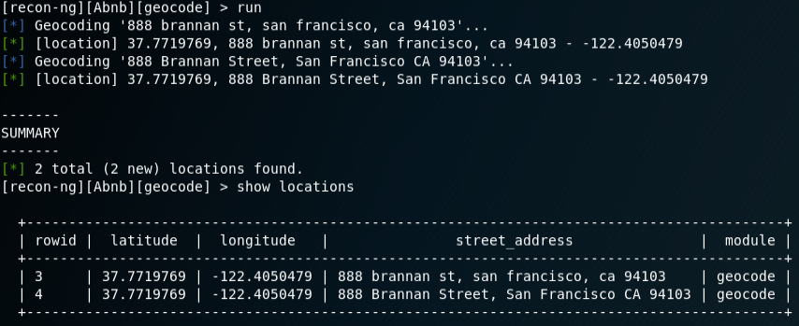

*Figure 7*. Screenshot of completed location table. Exact latitude and longitude coordinates are retrieved from the address. Commands used: recon/locations-locations/geocode.

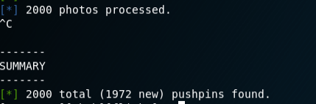

*Figure 8*. Screenshot of results of flickr metadata that matches the location table. Please note that the search was stopped early due to the mass number of photos recovered. Commands used: recon/locations-pushpins/flickr.

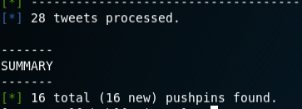

*Figure 9*. Screenshot of results of Tweets made in the area with metadata matches to the location table. Reminder that these Tweets are only available if the Twitter account had geo location services enabled. Commands used: recon/locations-pushpins/twitter.

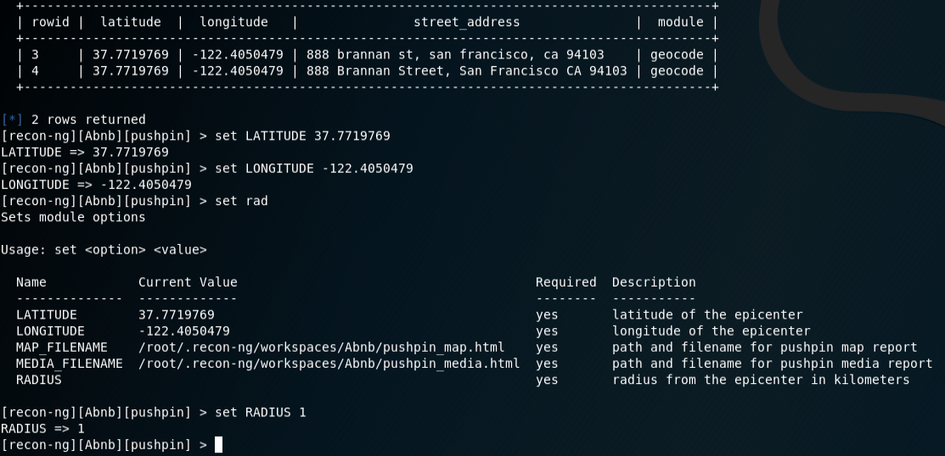

*Figure 10*. Screenshot of setting the parameter for the pushpin report command. Although the location table is complete, the report requires manual input of latitude, longitude, and radius. Commands used: reporting/pushpin.

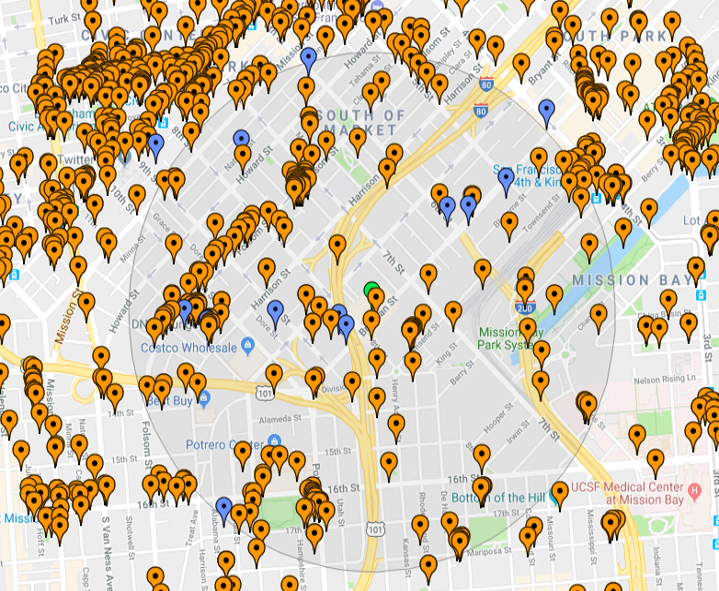

*Figure 11*. Screenshot of the pushpin results of the Flickr and Twitter findings in map form. Commands used: reporting/pushpin.

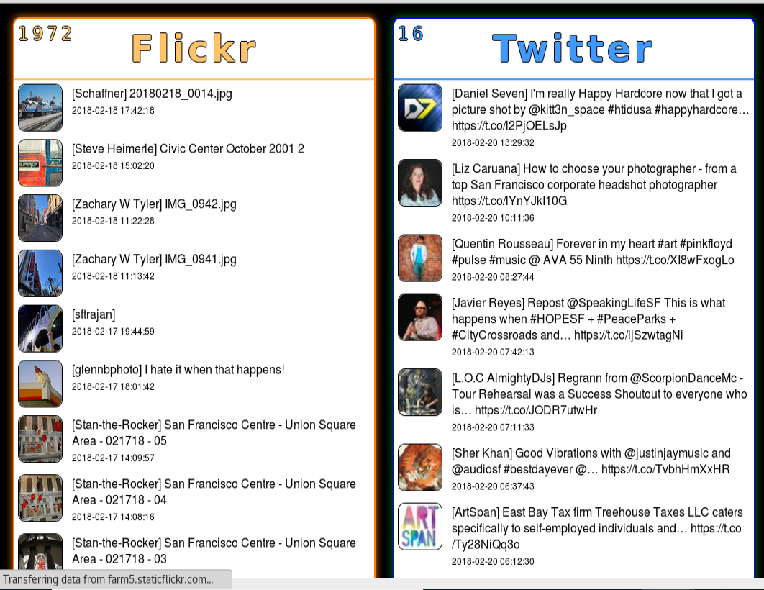

*Figure 12*. Screenshot of the Flickr and Twitter findings in an easy to search info graph. Commands used: reporting/pushpin.

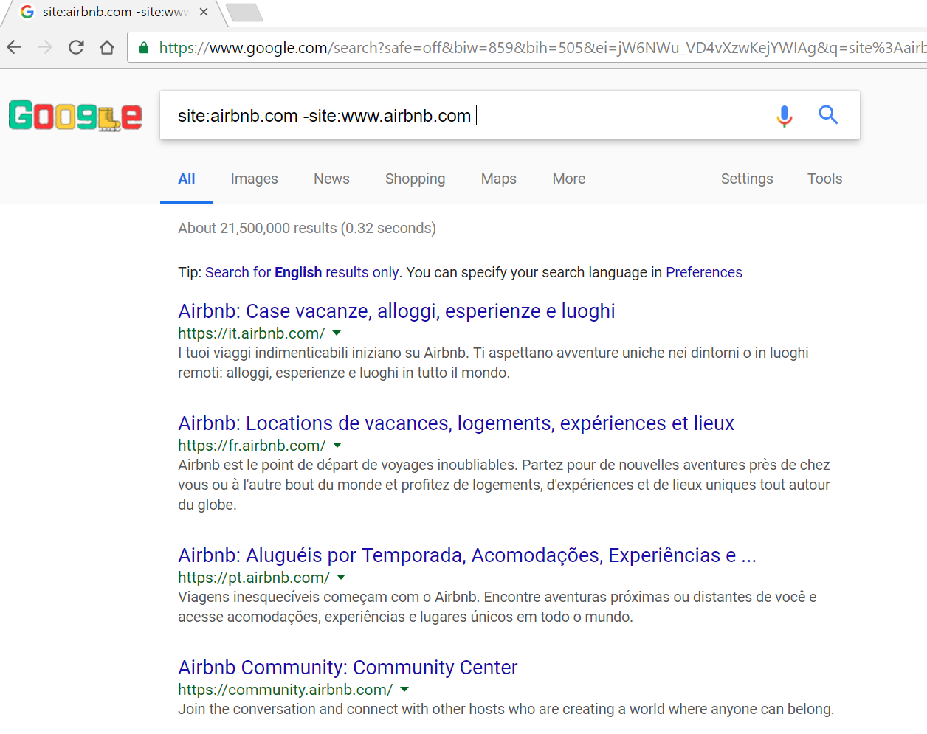

*Figure 13*. Screenshot depicting the initial starting point of site crawling. Commands used: site:Airbnb.com-site:www.airbnb.com

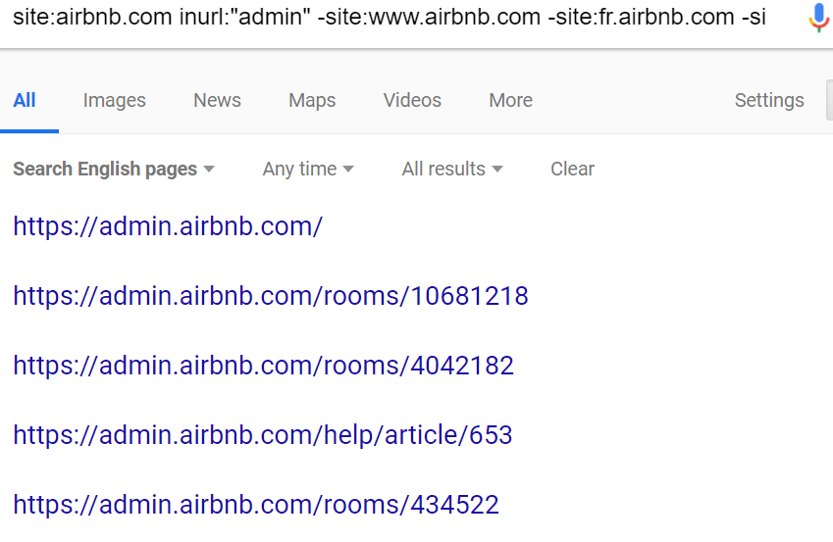

*Figure 14*. Completed search of the admin hosts through site crawling. Commands used: site:Airbnb.com inurl:”admin” -site:*.airbnb.com X (as many times as needed to obtain results)

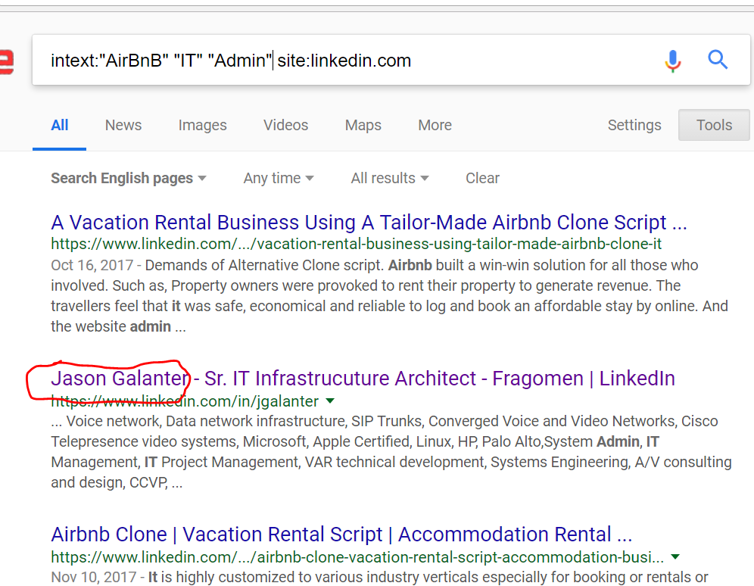

*Figure 15*. Screenshots of results for locating Airbnb admins via LinkedIn. This search provided information on the whois point of contact of the Airbnb domain and hosts. Commands used: Intext:”AirBnB” “IT” “Admin” site:linkedin.com



*Figure 16.* Screenshot of Admin employee search for AirBnB headquarters in San Francisco. Commands Used: Intext:”Airbnb” “IT” “Admin” “San Francisco” site:linkedin.com -www.linkedin.com/jobs (to omit job postings for AirBnB)

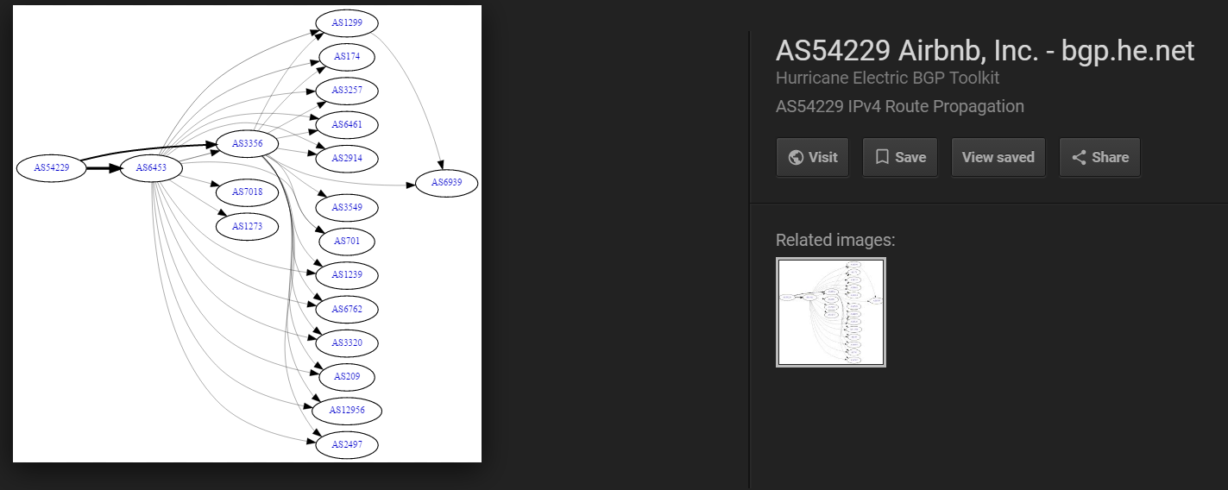

*Figure 17.* Screenshot of AirBnB IPv4 route propagation chart image found on a contractor’s website. Possible relevance to the UK servers.

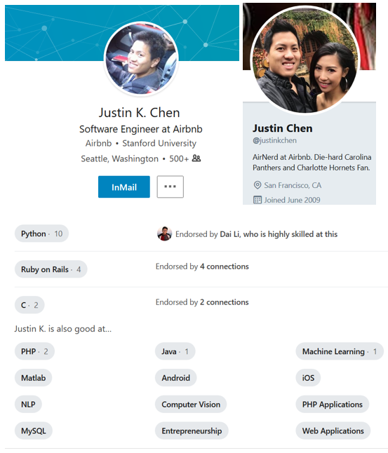

*Figure 18*. Screenshot of a LinkedIn and Twitter profile from an engineer at Airbnb.

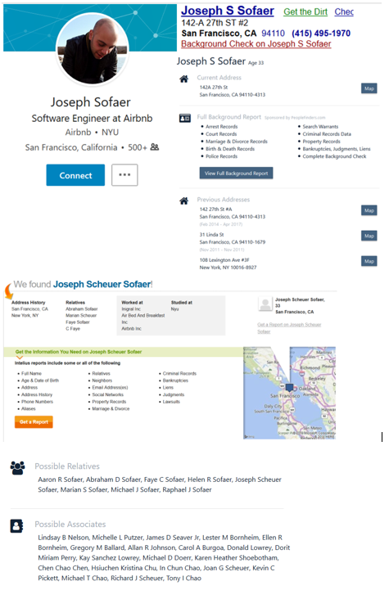

*Figure 19*. Screenshot of a LinkedIn profile and results from Familytreenow search for an engineer at Airbnb.

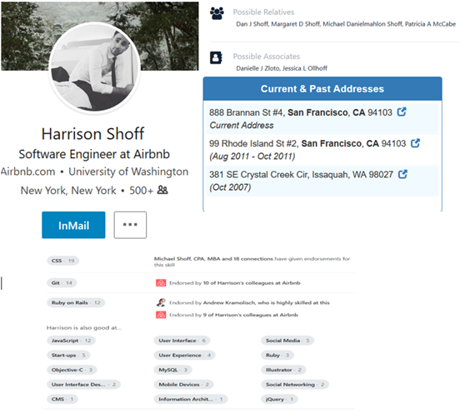

*Figure 20*. Screenshot of a LinkedIn profile and results from Familytreenow search for a software engineer at Airbnb.

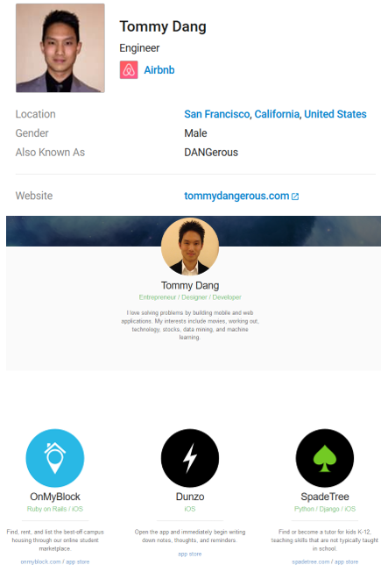

*Figure 21*. Screenshot of a LinkedIn profile and website of an Airbnb engineer.

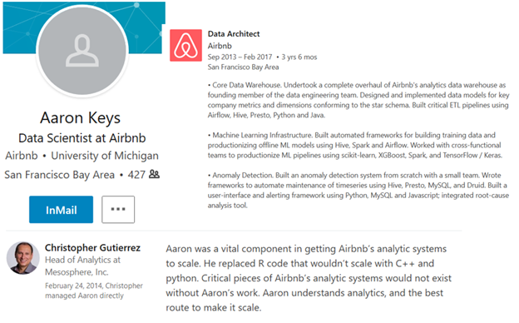

*Figure 22*. Screenshot of a LinkedIn profile from a data scientist at Airbnb.



*Figure 23*. Screenshot of a former admin at Airbnb.

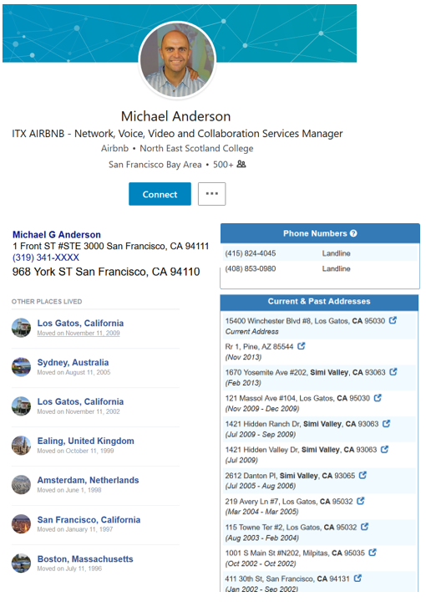

*Figure 24*. Screenshot of a LinkedIn profile and results from Facebook addresses,Zabasearch, and Familytreenow search.

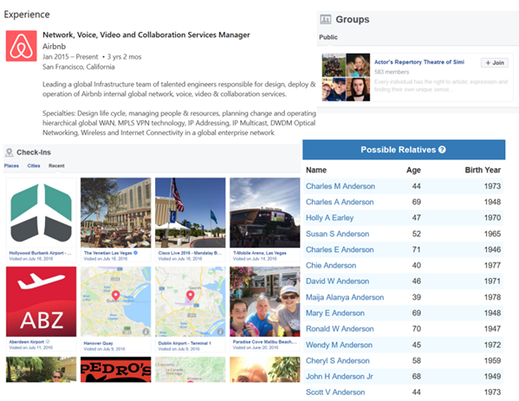

*Figure 25*. Screenshot of Anderson’s check-ins and groups from Facebook as well as experience from LinkedIn and possible relatives from Familytreenow search.

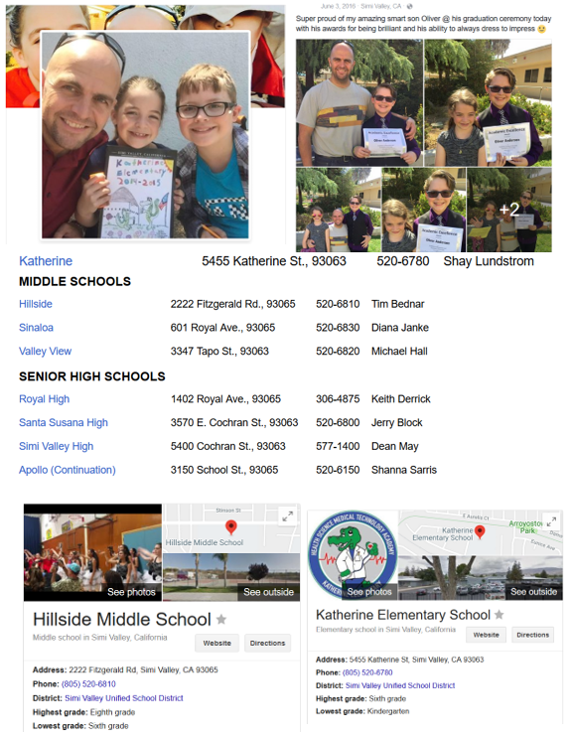

*Figure 26*. Screenshot of Anderson’s Facebook pictures of his children with the names of the schools as well as investigation into what schools they attend.

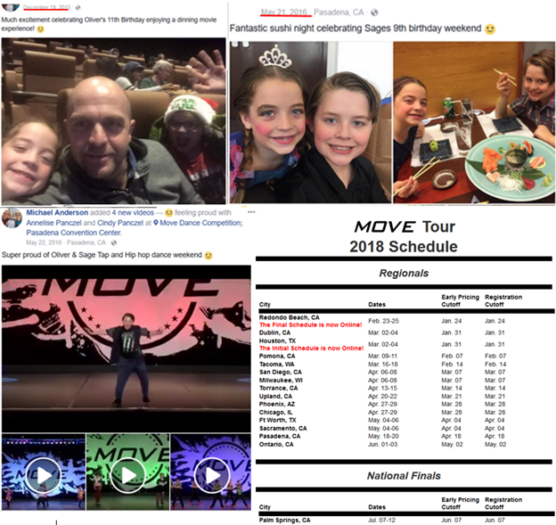

*Figure 27*. Screenshot of Anderson’s Facebook pictures of his children’s birthdays and dance competition as well as investigation into dates for competition.

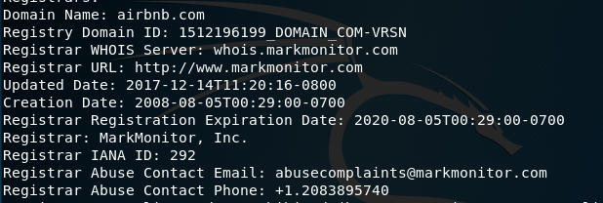

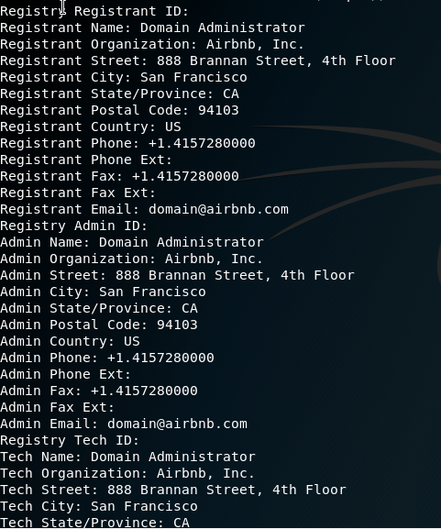

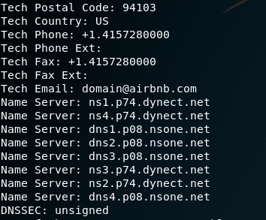

*Figure 28.* Screenshots of whois command for the domain Airbnb.com including locations and other information on the Company such as phone numbers and titles and name servers.

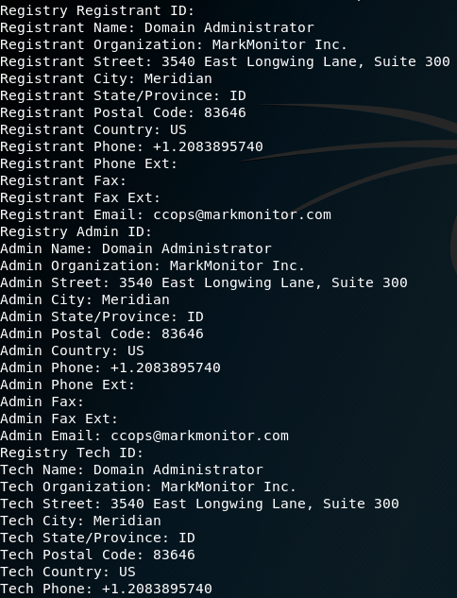

*Figure 29.* Information on the domain administrator who obtained the domain name for airbnb showing where he is located and also his phone number and title name as well. This information is the registrant ID.

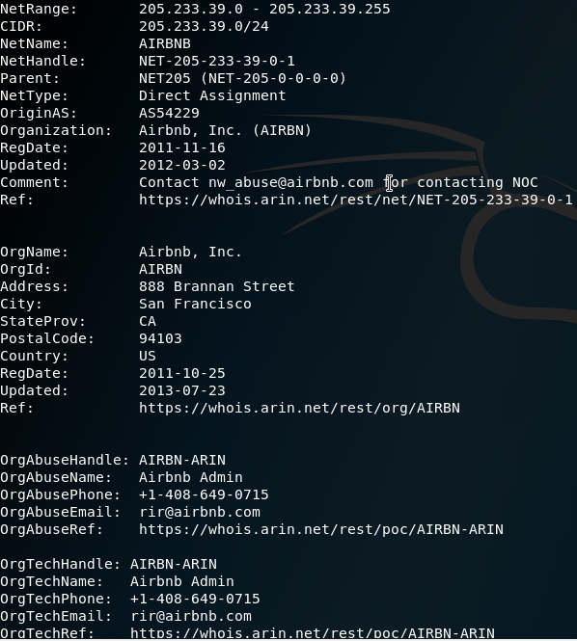



*Figure 30.* Information using the whois command on the given domain IP Address from a simple google search of AirBnB ip addresses. Gave a new email address also a new phone number and the registration date for the IP Address and the last Updated date for the IP Address.

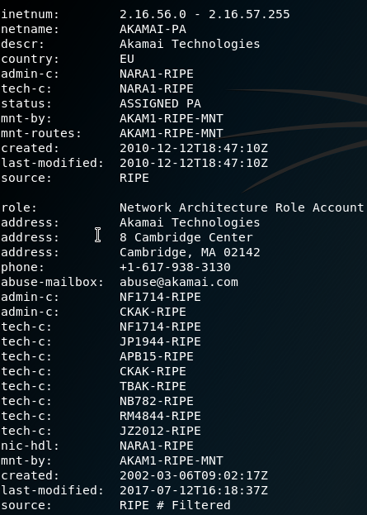



*Figure 31.* Whois command for the netcraft search for AirBnB resulting in a whole new ISP who distributed the domain to the website. This also gave the location of one of the american branches as this seems to be a primarily European ISP.

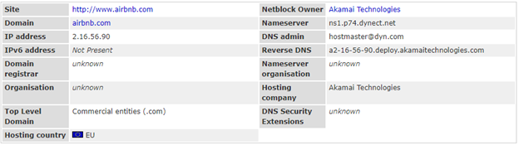

*Figure 32.* Netcraft search for the domain name airbnb and the associated entities with the corporation including the ip address of the ISP that gave the company their domain and name server and also DNS and Reverse DNS information.

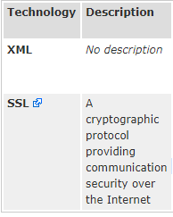

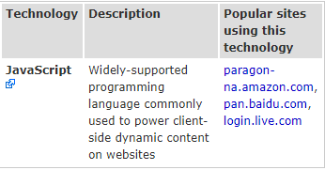

*Figure 33.* Information on the company’s server side and client side which was simplistic and only used a few different technologies and also displayed other sites that used these 3 technologies for their websites.

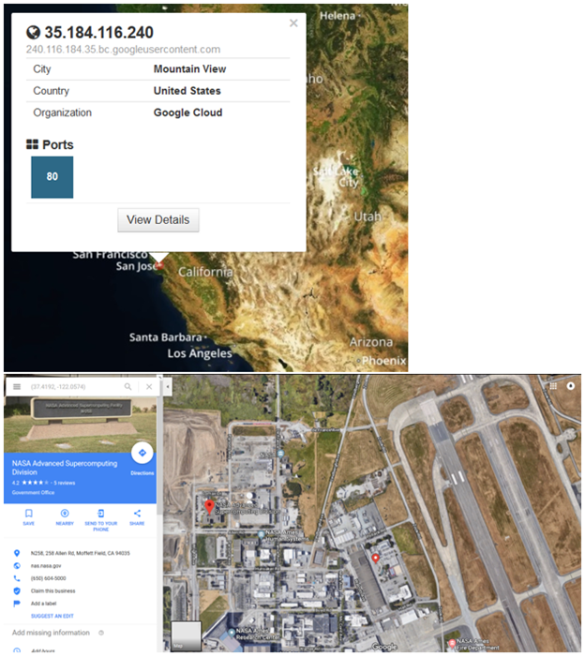

*Figure 34*.  Screenshot of first location from Shodan search.

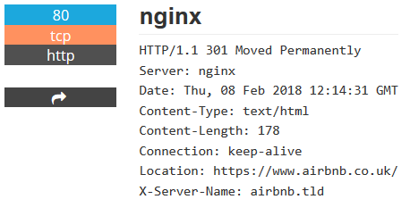

*Figure 35*.  Screenshot of a port and some of its properties.

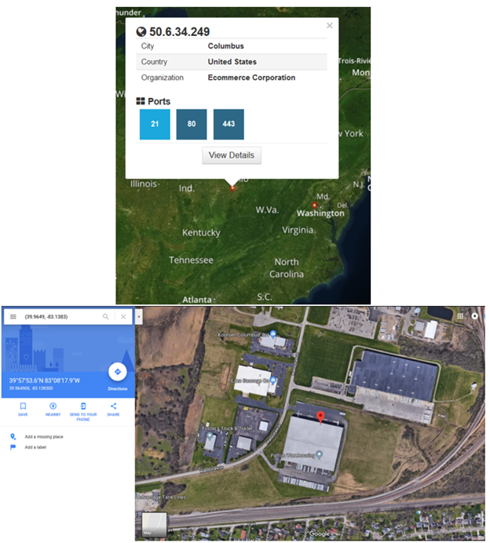

*Figure 36*.  Screenshot of second location from Shodan search.

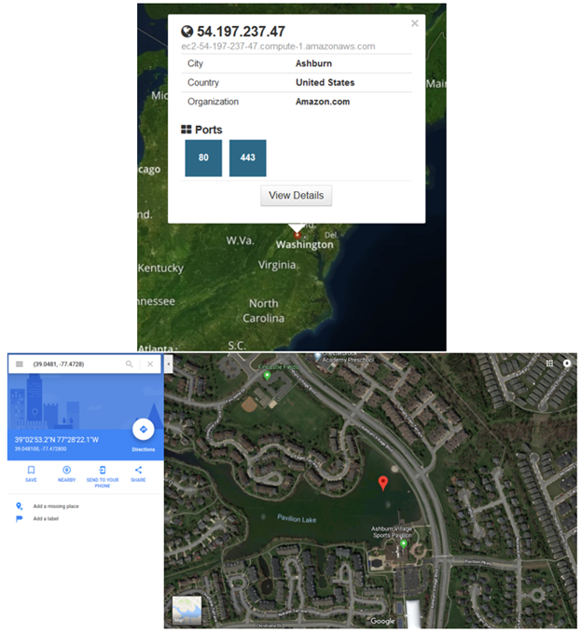

*Figure 37*.  Screenshot of third location from Shodan search.

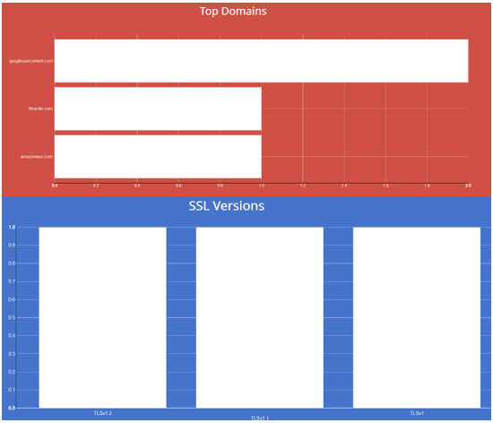

*Figure 38*.  Screenshot of top domains and SSL versions from Shodan.

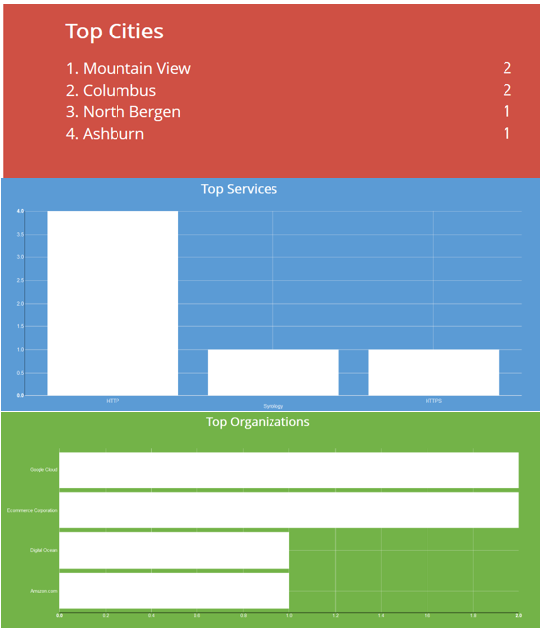

*Figure 39*.  Screenshot of top cities, services, and organizations from Shodan.